Press Release

February 19, 2025

Major efficiency driver:   
Westfalen Group Future-Proofs Its Processes with Aucotec

* **Centralized data platform: Aucotec's Engineering Base optimizes engineering and maintenance processes and preserves valuable know-how.**
* **Next-level digitalization: SAP integration and AI-driven workflows increase transparency, reduce errors, and improve data quality.**
* **Driver of innovation: Engineering Base enables significant advancements in technological development.**

Specializing in gases, heating and cooling, and sustainable mobility, the Westfalen Group has put its trust in the Engineering Base cooperation platform from Aucotec. This is mainly due to the platform's ability to serve as a single source of truth for end-to-end, error-free planning and documentation.

**Transparency and efficiency in engineering**

The spectrum of products and services offered by the Westfalen Group is increasingly focused on sustainable energy solutions, particularly hydrogen. To streamline internal processes, the company was looking for a software solution that would provide optimum support for both the maintenance and engineering of its own production sites. "We wanted to establish a centralized data storage system that would create transparency throughout the entire life cycle of our plants and allow easy redlining," explains Laurent Wauters-Herlyn, Head of Strategy & Innovation for Production & Engineering at the Westfalen Group. "All relevant disciplines were to be consolidated on a common software platform rather than using multiple solutions."

**The solution: Engineering Base as a centralized data platform**

During the software selection process, Aucotec's Engineering Base emerged as the ideal solution. The platform integrates CAD, E-CAD, process engineering and EI&C engineering into a central data model, enabling consistent, error-free planning. "Engineering Base links all relevant data in a central environment," continues Wauters-Herlyn. "The capability for AI-driven optimization was another crucial factor. Demographic changes pose the challenge of preserving knowledge over the long term while unlocking further efficiency potential.”

Westfalen expects implementation of the Aucotec platform to bring significant efficiency gains and additional benefits:

• Engineering: 11% reduction in costs

• Maintenance: 15% less planning effort

• Minimization of errors thanks to centralized data storage

• AI-driven engineering based on preserved knowledge resources

**Integration with SAP and continued growth**

With the planned switch to SAP S/4 HANA, Westfalen sees the integration of SAP with Engineering Base as a promising opportunity. "The potential link-up with SAP further increases efficiency and enables seamless digital documentation," remarks Wauters-Herlyn.

By opting for Engineering Base, Westfalen has embraced an innovative and sustainable solution that not only meets current requirements, but also actively addresses future challenges in the energy sector. "We are proud of our collaboration with Westfalen and grateful for the trust placed in our data-centric platform," explains Stefan Wedderkopp, Global Sales Director Process Plants at Aucotec. "Engineering Base not only assists companies with digitalization, it also enables them to strategically optimize their processes and future-proof them."

**Images* and captions:**

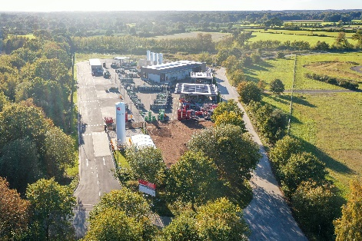

Creating value directly from efficient planning: the modern [gas filling plant in Lanken](https://www.aucotec.com/fileadmin/user_upload/Company/Pressemitteilung/2025/2_2025/Westfalen-Werk-Lanken.jpg) in northern Germany is one of over 20 production sites operated by the Westfalen Group in Europe. (Photo: Westfalen AG)

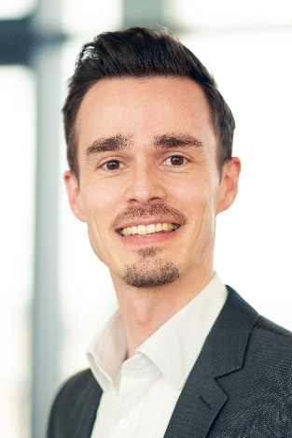

[Laurent Wauters-Herlyn](https://www.aucotec.com/fileadmin/user_upload/Company/Pressemitteilung/2025/2_2025/Laurent_Wauters-Herlyn.jpg), Head of Strategy & Innovation for Production & Engineering at the Westfalen Group. (Photo: Westfalen AG)

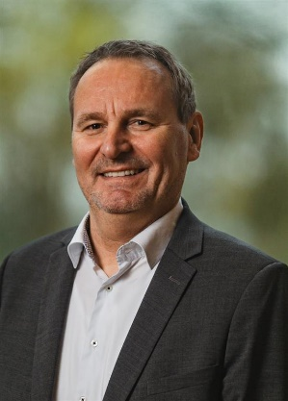

[Stefan Wedderkopp](https://www.aucotec.com/fileadmin/user_upload/Company/Pressemitteilung/2025/2_2025/Stefan_Wedderkopp.jpg), Global Sales Director Process Plants at Aucotec. (Photo: Aucotec)

*These images are protected by copyright. They may be used for editorial purposes in connection with Aucotec and the Westfalen Group.

___________________________________________________________________________

[**Aucotec AG**](https://www.aucotec.com/) has almost 40 years' experience in the development of engineering software designed for use throughout the life cycle of machinery, plant equipment and mobile systems. Solutions range from flow diagrams and process-control/electrical technology for large-scale plant systems to modular on-board power supply units designed for the automotive industry. Software supplied by Aucotec is currently in operation throughout the world. In addition to the headquarters near Hanover, the Aucotec Group includes six other locations in Germany as well as subsidiaries in China, India, Malaysia, South Korea, the Netherlands, France, Italy, Austria, Poland, Sweden, Norway and the USA. What is more, a global partner network ensures local support all over the world.

We would be grateful if you could supply us with a copy of your article. Thank you very much!

**Contact:**

**AUCOTEC AG**, Hannoversche Straße 105, 30916 Isernhagen, www.aucotec.com

Public Relations, Arne Peters ([arne.peters@aucotec.com](mailto:arne.peters@aucotec.com) +49(0)511-6103192)