Press Release
June 26, 2024
Aucotec personnel news: Dr. Florian Jurecka takes over as new Vice President Global Sales and Marketing
Aucotec strengthens executive team and brings together its marketing and sales activities

Dr. Florian Jurecka (49) was appointed to the newly created post of Vice President Global Sales and Marketing at Aucotec AG on June 1, 2024. Reporting directly to the Board of Management, Dr. Jurecka will be responsible for the strategic development of the sales and marketing activities across the entire Aucotec Group, which are being brought together under his leadership.

Over the past eleven years, Dr. Jurecka has held a series of executive positions at Dassault Systèmes and was most recently in charge of the French market leader's global CAE business unit, SIMULIA. After studying civil engineering, he completed his doctorate at the Technical University of Munich's Chair of Structural Analysis, before going on to obtain a masters in Innovation Management at the same institution. His ability to closely intertwine technical engineering expertise with sales and marketing know-how has shaped his whole career.

Technical expertise paired with sales and marketing know-how
"With the arrival of Dr. Florian Jurecka, we have gained an outstanding executive capable of offering strategic vision on both the technical and the sales and marketing side. He has a high level of familiarity with the engineering software market going back many years now and understands exactly what our customers and partners need," says Uwe Vogt, Board Member of Aucotec. "Dr. Jurecka has been a driving force at an international level in efforts to establish a platform approach in the engineering market. We are delighted that he has now joined us to reinforce our executive team in his new role. His many years of management experience in the software industry, from start-ups through to multinationals, will help us achieve our goals and expertly drive our continued growth worldwide."

Following Dr. Florian Jurecka's appointment as Vice President, Uwe Vogt will focus on his Board role and help shape the company's sustained dynamic growth.

Forging ahead with internationalization
Dr. Jurecka also sees his new role as a logical step forward: "Aucotec is synonymous with top-class, innovative solutions, maximum focus on the customer and outstanding quality in this industry. And most importantly of all, they have a fantastic, strong team, with whom I will be tackling the task ahead. I'm really impressed by how Aucotec is successfully implementing and pressing ahead with data-driven transformation in engineering." He concludes: "My enthusiasm for technical innovations, such as digital twins and artificial intelligence and their influence on us as individuals, companies and even as a society, is something I can contribute very well at Aucotec. I'm very much looking forward to this exciting role and the responsibilities it brings."

Images* and captions:

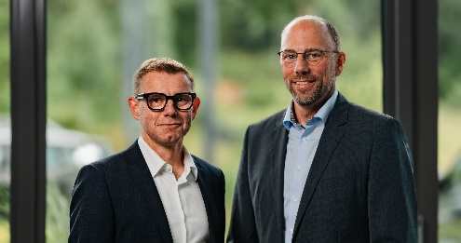

Uwe Vogt, Board Member (left) and Dr. Florian Jurecka, Vice President Global Sales and Marketing at Aucotec (right)

*These images are protected by copyright. They may be used for editorial purposes in connection with Aucotec.

___________________________________________________________________________
Aucotec AG has more than 35 years' experience in the development of engineering software designed for use throughout the life cycle of machinery, plant equipment and mobile systems. Solutions range from flow diagrams and process-control/electrical technology for large-scale plant systems to modular on-board power supply units designed for the automotive industry. Software supplied by Aucotec is currently in operation throughout the world. In addition to the headquarters in Hanover, the Aucotec Group includes six other locations in Germany as well as subsidiaries in China, India, Malaysia, South Korea, the Netherlands, France, Italy, Austria, Poland, Sweden, Norway and the USA. What is more, a global partner network ensures local support all over the world.

If printed, we would appreciate receiving a copy of your article. Thank you very much!

Contact:
AUCOTEC AG, Hannoversche Straße 105, 30916 Isernhagen, www.aucotec.com
Public Relations, Arne Peters (arne.peters@aucotec.com +49(0)511-6103192)

