Press Release
May 29, 2024
On course for growth: another record year for Aucotec
- Software company records sales of around 29 million in the past financial year
- Focus on decarbonization and energy systems solutions
- Asia and Europe remain number one growth markets

The software company Aucotec closed its past financial year, ending at the end of March, with yet another sales record. The engineering software specialist from Isernhagen near Hanover recorded sales of around EUR 29 million – more than 13% higher than in the previous year, which was also a sales record. Incoming orders rose by just over 9% and currently stand at around EUR 40 million.

"The figures – even if they are still provisional – prove that we have worked well in recent years and made the right decisions," says Uwe Vogt, member of the Aucotec Management Board. "The challenges in the industry sectors were and are diverse, but above all, solutions for a networked and climate-neutral industry are at the heart of our business. We are making a decisive contribution to this with our Engineering Base software platform."

Megatrends digital transformation and sustainability
For Aucotec, these are positive signals for the coming year, which will be a special one: Aucotec will be 40 years old in 2025 – a strong anniversary for a software company: "In these 40 years, we have enabled innovations in so many industries with our products and solutions," emphasizes Vogt. "Engineering Base, for example, has been established on the market for years, and the platform is constantly being expanded to meet new requirements and provide solutions for our customers."

Technology and sustainability go hand in hand
Of particular note are Engineering Base's assignments with international customers who are pioneers in decarbonization and the expansion of energy grids. Keyword green hydrogen. Keyword energy transition. Last but not least, automotive and railroad manufacturers play a key role in Aucotec's portfolio.

Aucotec now employs over 260 people worldwide in twelve subsidiaries in Europe, North America and Asia. As in previous years, the latter remains an important focus market: "We continue to see enormous potential for our solutions in many areas – turnover and response in the regions underline this," says Vogt.

Images and visuals*:

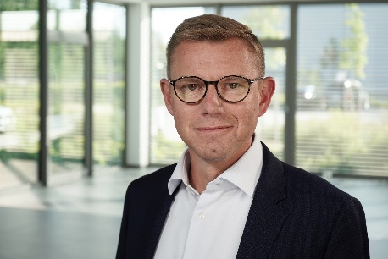
Uwe Vogt, member of the Aucotec Management Board: "The figures – even if they are still provisional – prove that we have worked well in recent years and made the right decisions." (Image: AUCOTEC AG)

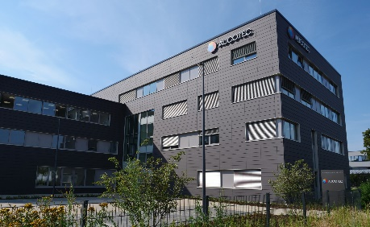
Continuing to grow: Aucotec headquarters in Isernhagen near Hanover. (Image: AUCOTEC AG)

*These images are protected by copyright. They may be used free of charge for editorial purposes in connection with Aucotec.

___________________________________________________________________________
Aucotec AG has more than 35 years’ experience in the development of engineering software designed for use throughout the life cycle of machinery, plant equipment and mobile systems. Solutions range from flow diagrams and process-control/electrical technology for large-scale plant systems to modular on-board power supply units designed for the automotive industry. Software supplied by Aucotec is currently in operation throughout the world. In addition to the headquarters in Hanover, the Aucotec Group includes six other locations in Germany as well as subsidiaries in China, India, South Korea, the Netherlands, France, Italy, Austria, Poland, Sweden, Norway and the USA. What is more, a global partner network ensures local support all over the world.

We would be grateful if you could supply us with a copy of your article. Thank you very much!
AUCOTEC AG, Hannoversche Straße 105, 30916 Isernhagen, www.aucotec.com
Public Relations, Arne Peters (arne.peters@aucotec.com, +49(0)511-6103192)

